**DynamoDB**

**Interacting with DynamoDB via AWS Console**

**Learning Objective:**

1. Observe differences between Partition vs Sort keys
2. Observe differences between Query and Scan
3. Create table **BikeStoreYOURNETID**
4. Add Primary Key – Bike_Id (Number)
5. Add Sort Key – Store_Id (Number)
6. Uncheck Use Default Settings
7. Uncheck Read Capacity and Write Capacity
8. Click Create

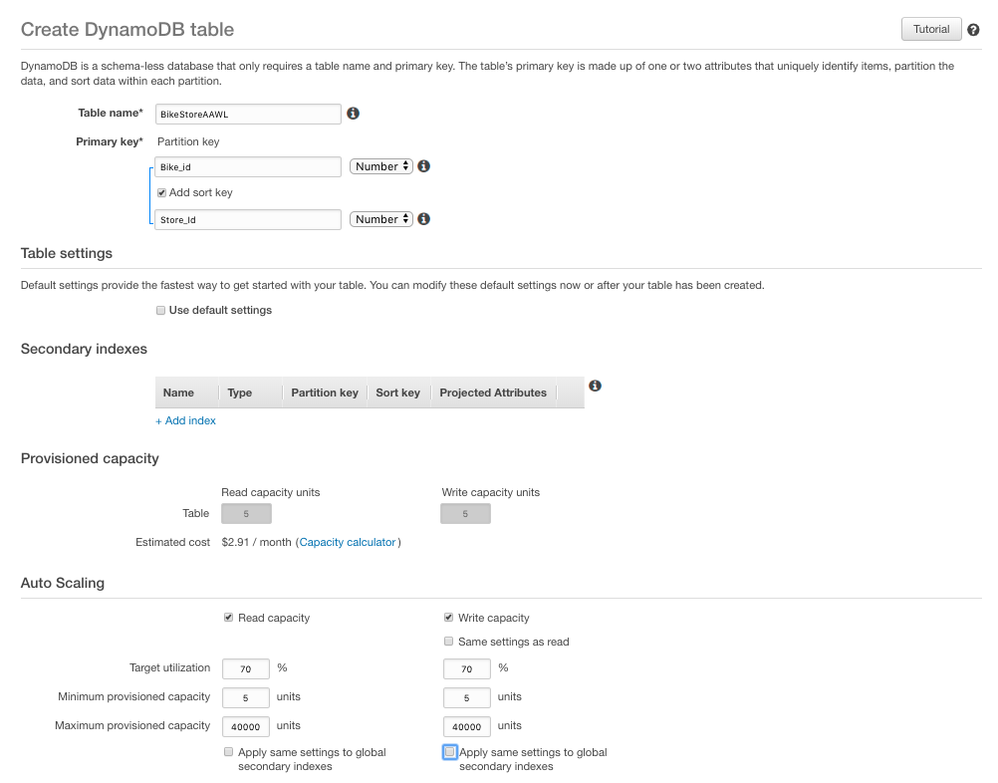

1. Enter 5 different items to **BikeStoreYOURNETID** table as follows:
2. Bike_id = 99; Store_Id = 4; color (string) = yellow
3. Bike_id = 23; Store_Id = 1; color (string) = blue
4. Bike_id = 23; Store_Id = 2; color (string) = black
5. Bike_id = 99; Store_id = 2; color (string) = green
6. Bike_id = 11; Store_id = 2; color (string) = green

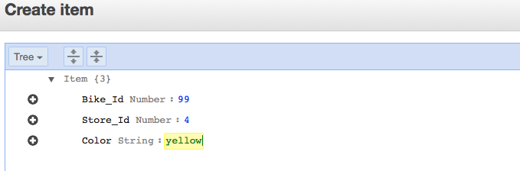

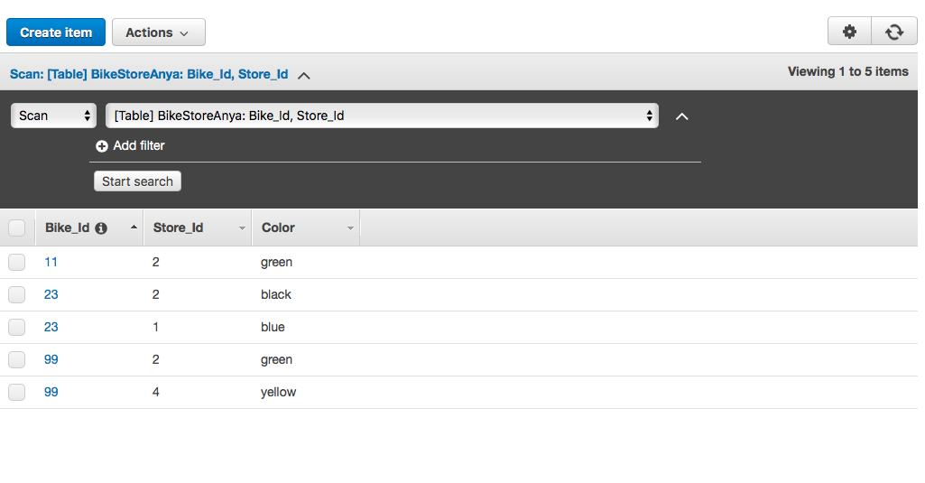

1. Let’s look at Query Option (based on Partition and Sort Key)
2. Choose Query from drop down list

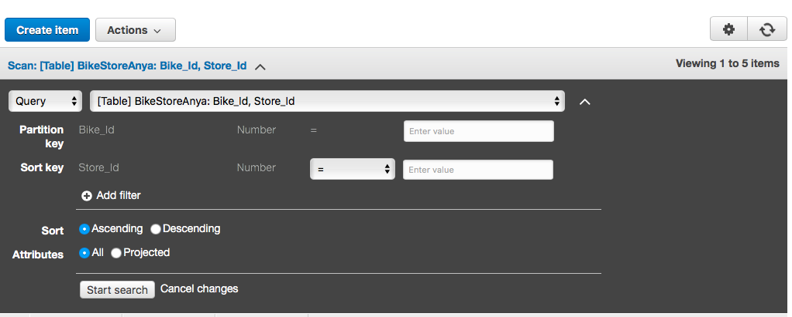

1. Observe that for Partition key can only query for specific value (chose 11 for demonstration)

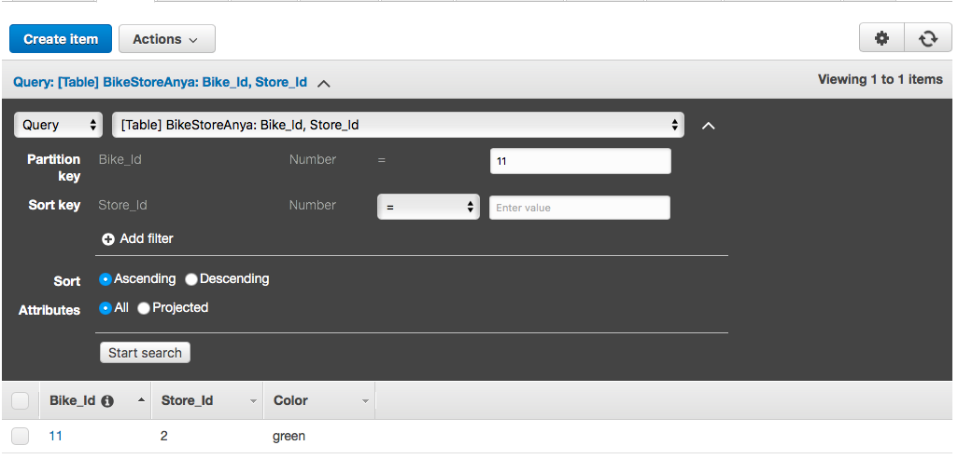

1. Observe that with Sort Key we can do more advanced lookup. Enter 23 for Partition Key and 2 for Sort Key:

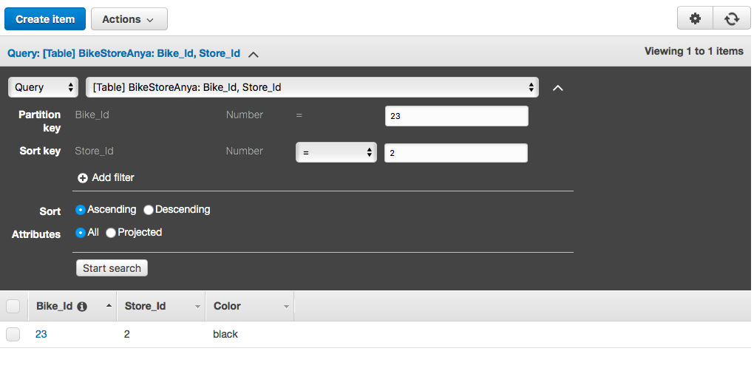

1. Exit out of table view